**Name: Sandra PM**

**Roll No:34**

**Batch:MCA**

**Date:09/05/22**

**NETWORKING&SYSTEM ADMINISTRATION LAB**

**Experiment No.: 15**

**Aim**

write a shell script for factorial of given number

**Procedure:**

#!/bin/bash

read -p "enter the number " num

fact=1

while [ $num -gt 1 ]

do

fact=$((fact*num))

num=$((num-1))

done

echo $fact

**output:**

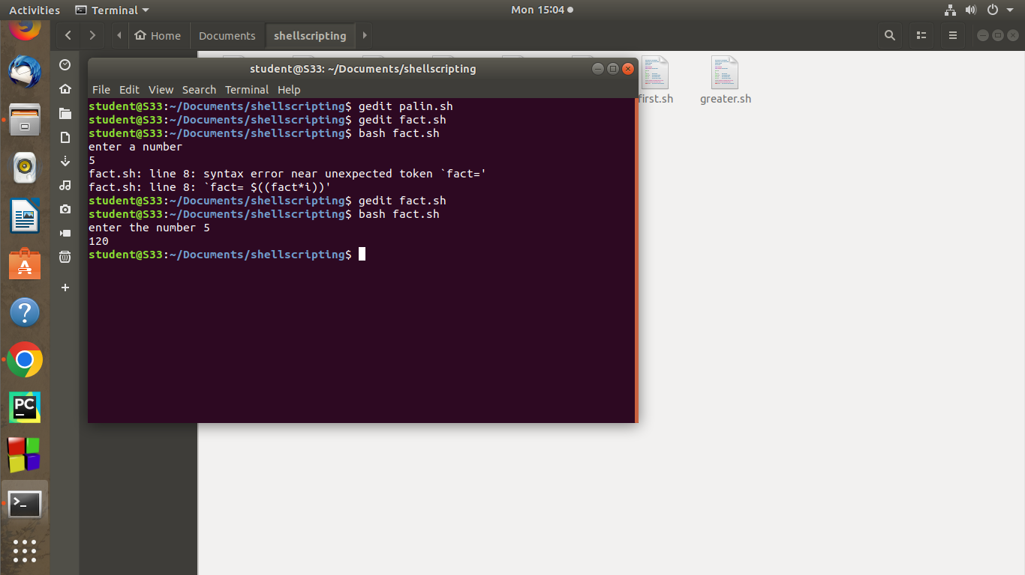

2. **locate-** to locate a particular file or directory .

Syntax:

$locate filename

**output:**

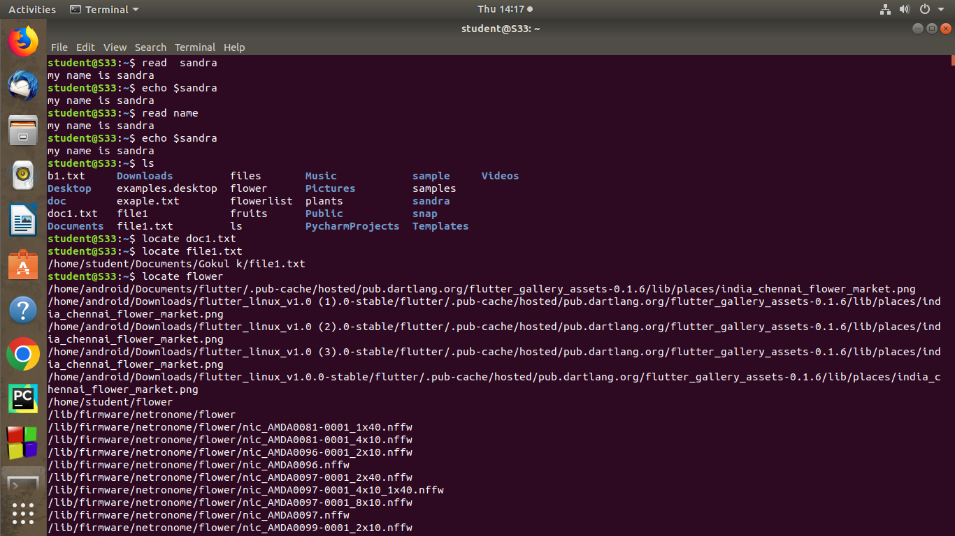

3. **locate ~~-i~~** -locate uppercase and lowercase

syntax:

**$locate -i**

**output :**

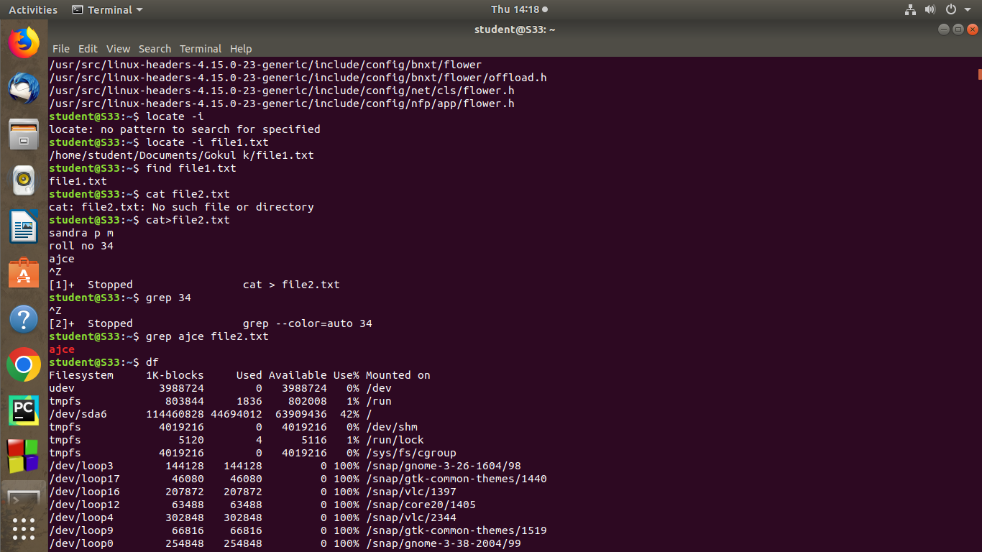

4.**find-** find current directory .

**syntax:**

**$**find filename

**output:**



**5.grep –** grep command will let you search all text in a given file.

Syntax:

$grep content filename

**output:**



6.**grep -i –** for a case insensitive search

**syntax:**

$grep -i word filename

**output:**

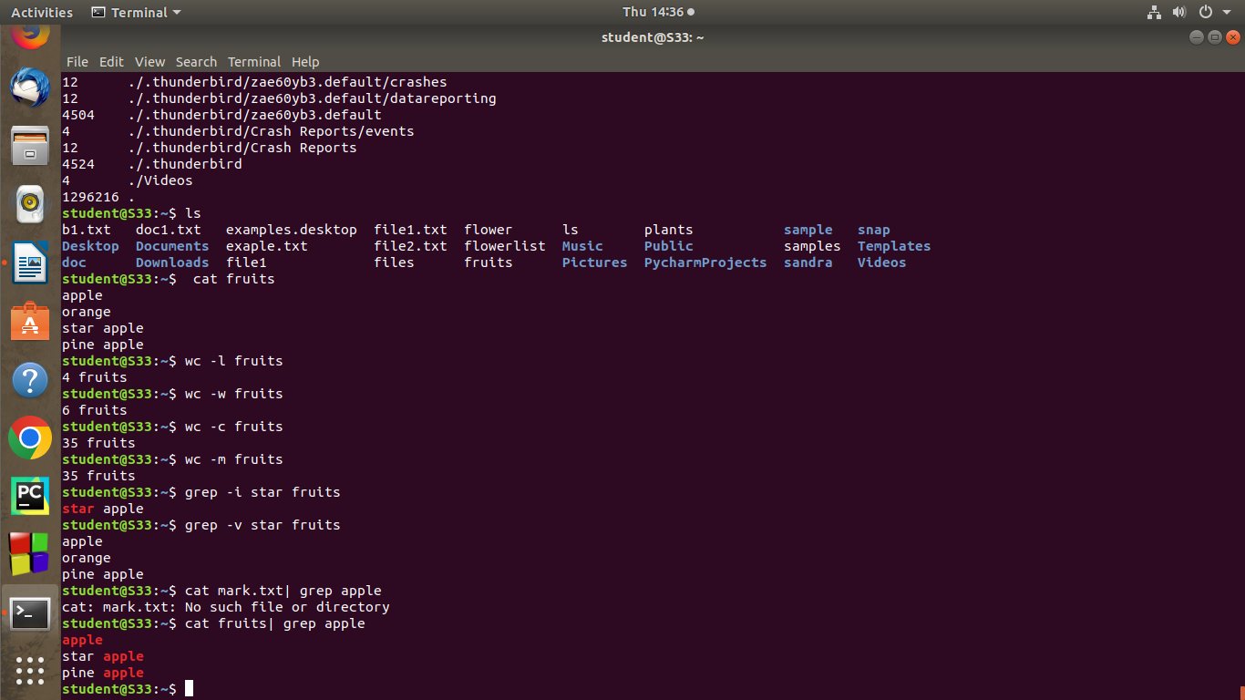

**7.**grep ~~-~~v - inverted search

**syntax:**

$grep -v word filename

**output**



**8.grep | -**search that particular word

**syntax:**

$ cat filename | grep word

**output**

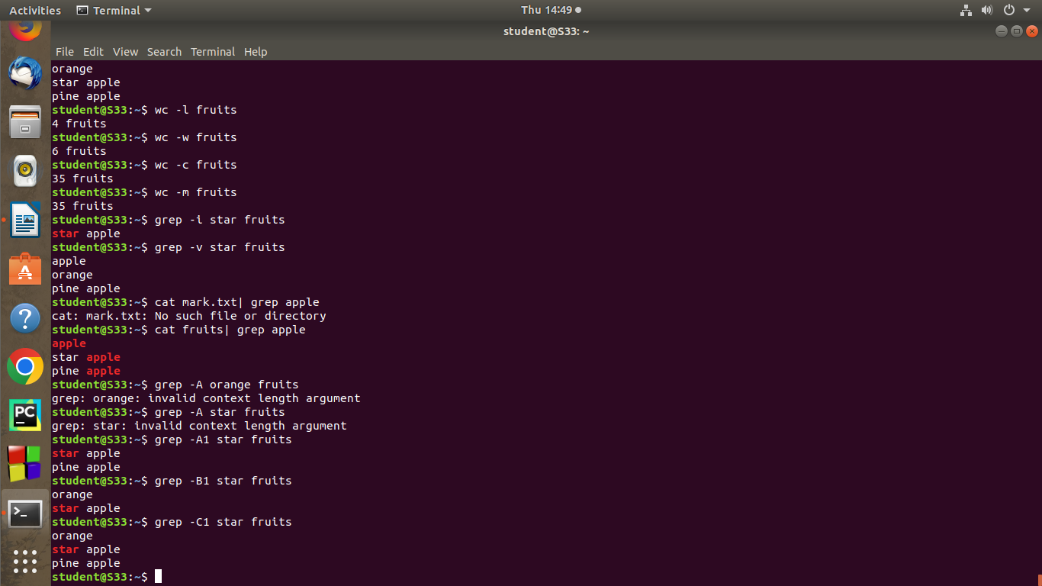

9.**grep -A1** – to display the line after the result.

**Syntax:**

**$**grep -A1 word filename

**output**



**1**0.grep -B1 -display the line before the result.

**Syntax:**

**$**grep -B1 word filename

**output**



**11.grep -C1** -display the line before and after the result

**syntax**

**$**grep -C1 word filename

**output**



**12.df -**df command is used to report of system diskspace usage.

**Syntax:**

$df

**output**

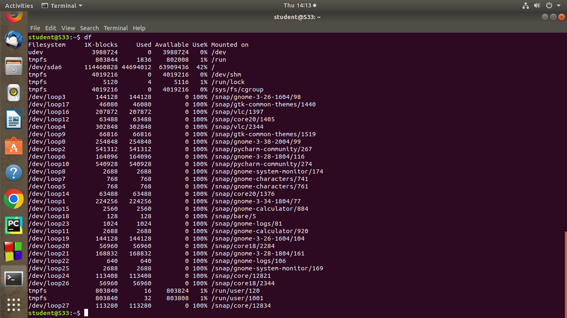

**13.du -**to check how much space a file or directory takes.

**Syntax**

**$ du**

**output**

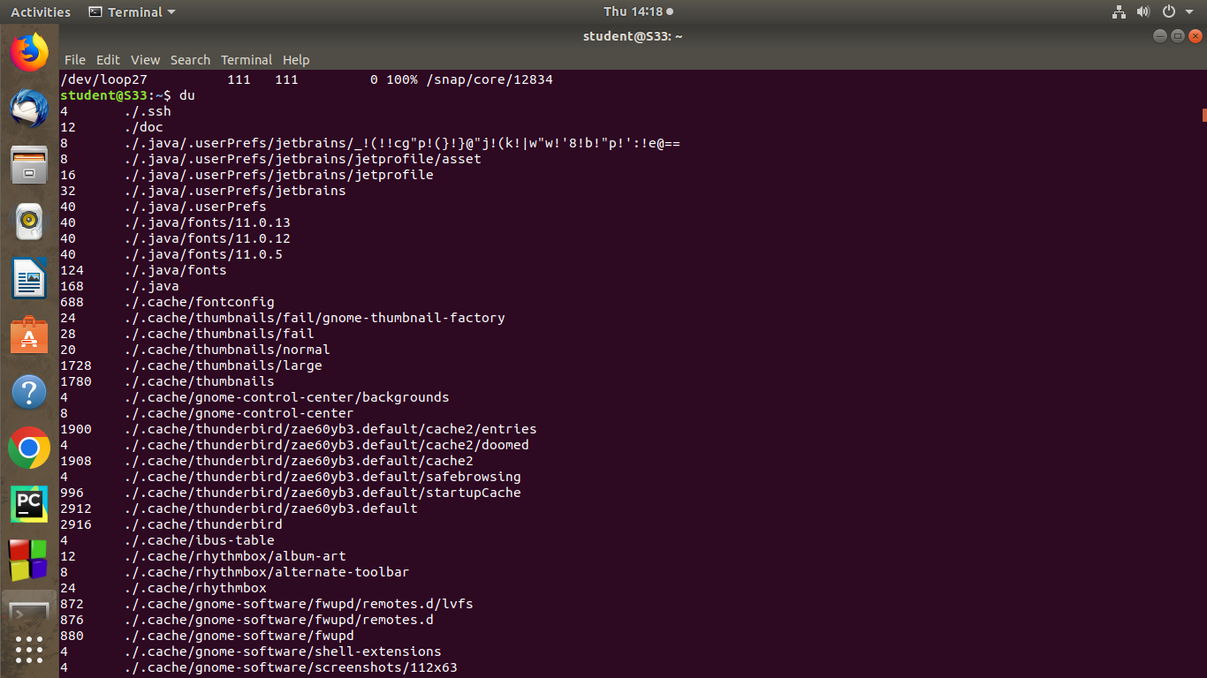

**13.wc –** word count used for count purpose it is used to find the number of lines ,number of words number of characters and number of bytes.

**Syntax**

**$ wc -l filename**

**$ wc -w filename**

**$ wc -c filename**

**$ wc -m filename**

**output**

